**Top Performing Products by Revenue**

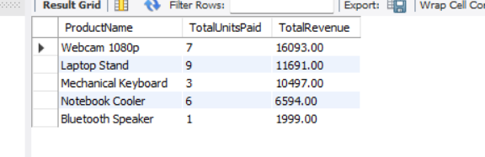

*Insight*: **Webcam 1080p** is the clear **revenue leader**, driven by both **strong demand and premium pricing**. **Laptop Stand** and **Mechanical Keyboard** follow closely, proving their combined appeal and profitability. **Lower-ticket items** like **Notebook Cooler** and **Bluetooth Speaker** contribute moderately, suggesting solid utility but limited upsell potential.

Doubling down on top earners like the Webcam with promotions, bundling, or ad spend, while exploring value-pack strategies to lift revenue from lower-volume products can help all products to generate good revenue.

**Average Order Value per Customer**

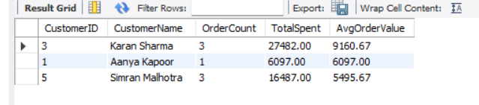

*Insight*: **Karan Sharma** leads in both total spend and average order value, signaling a high-value customer with strong purchase intent. **Aanya Kapoor**, despite a single transaction, shows significant value per order, making her a strong candidate for targeted retention efforts. **Simran Malhotra** maintains steady spending across multiple orders, indicating consistent engagement and long-term potential.

Prioritizing loyalty rewards or early-access offers for **Karan Sharma** and **Simran Malhotra**, and re-engaging **Aanya Kapoor** to convert her high-value interest into repeat purchases will lead to high average order value per customer with completed payments.

**Customers with High Attempted Spend but Low Successful Payments**

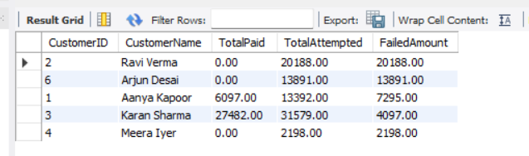

*Insight*: A significant portion of **high-value payment attempts** remain **unsuccessful**, highlighting **potential friction** during **checkout or post-payment cancellations**. These failed transactions represent substantial lost revenue opportunities. The gap between attempted and completed payments suggests a **need to optimize the payment experience, reinforce trust at checkout, and implement recovery mechanisms** such as **payment retries, reminders, or fallback options.**

Addressing these drop-offs can directly improve revenue realization without acquiring new customers, by converting existing interest into successful sales.

**Revenue by Payment Method**

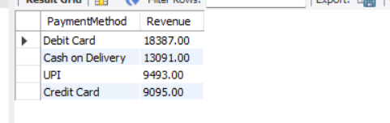

*Insight*: **Debit Card** leads as the **most reliable revenue channel**, followed by **Cash on Delivery**, which still holds a significant share despite its logistical overhead. **UPI and Credit Card lag behind**, potentially due to failed transactions or user drop-offs during payment. This disparity may indicate friction in digital checkout flows or limited trust in these methods.

Continuing prioritizing Debit Card stability and exploring optimizing UPI and Credit Card experience, through faster gateways, payment retries, or trust badges, to reduce friction and recover revenue.

**Unit Economics per Product**

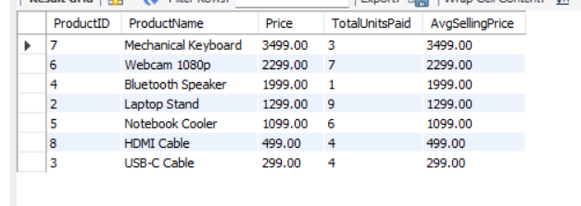

*Insight*: All products are maintaining their **listed price as the average selling price**, indicating **no discounts or price variability**. This suggests strong pricing discipline and consistent customer willingness to pay full price. **Webcam 1080p** and **Laptop Stand** have higher volumes sold at full price, reinforcing their perceived value and market fit. Meanwhile, premium items like the **Mechanical Keyboard** and **Bluetooth Speaker** have lower units sold, hinting at **price sensitivity** or limited reach despite high unit profitability.

Maintaining current pricing for high-turnover items like **Webcam 1080p**, while experimenting with **limited-time offers** or bundles for premium, slower-moving products to boost conversion without eroding perceived value.

**Product Demand vs Stock Left**

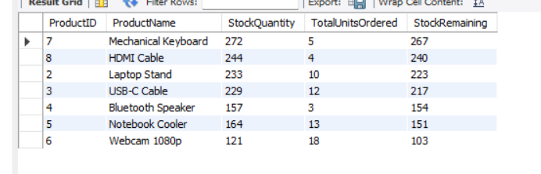

*Insight*: **Webcam 1080p** and **Notebook Cooler** exhibit strong market traction, with a significant portion of their inventory already sold. This high velocity suggests they are top-performing SKUs with strong customer demand. **Mechanical Keyboard** and **Laptop Stand** show slower inventory turnover, despite sufficient stock levels. This indicates possible product saturation or weaker market pull.

**Strategic discounting**, **bundled offers**, or repositioning in marketing campaigns could help unlock this stagnant inventory and optimize working capital.

**Order Fulfillment Analysis**

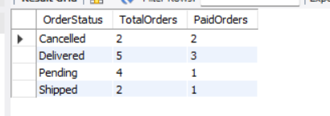

*Insight*: The **Pending** and **Delivered** orders show incomplete payment conversions, with only 25% and 60% respectively being fully paid. It hints potential bottlenecks in the payment or confirmation process. Interestingly, **all Cancelled orders were already paid**, suggesting possible post-payment drop-offs or refund triggers. This warrants deeper investigation into cancellation reasons to prevent revenue leakage.

Streamline payment follow-ups for Pending and Shipped orders. Add confirmation prompts before payment for high-risk cancellation segments to reduce revenue loss.